**Create a Map chart showing the number of transactions processed in each region.**

**Solution:**

Select Sheet1 once the dataset "Bank Data" is connected to the workbook.

Firstly, let's change the Data type of Region Dimension.  Right click on the data type Region dimension and change the geographic role to State/Province.

Select Region under Dimensions and choose Filled Map under 'Show Me' Section.

Click on the '4 Unknown' display at the bottom of the map and select Edit Location from the pop up window. Change Country/Region to UK.

Drag and drop Region and No. of Records to Label under Marks Card. Likewise,  drag and drop Region to Color under Marks card to showcase regions in different colors.

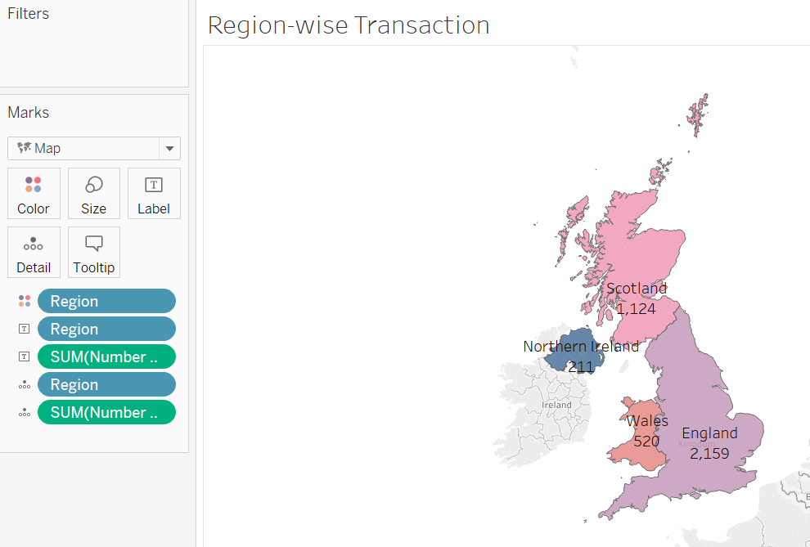

**Insights**

{i} England leads in terms of No. of transactions followed closely by Scotland.

(ii) Northern Ireland is at the bottom with 211 transactions.

•**Create a Pie chart displaying the percentage of each transaction processed between genders**.

Hold ctrl button and select 'Gender' dimension along with 'Number of Records' measure and choose "Pie Chart" under Show Me section.

Drag and drop Gender and No. of records on label under Marks card. Drag and drop Gender on to color.

Click on 'No. of Records' label and select Quick table calculation, select Percent of Total option. The label will now display in terms of percentage.

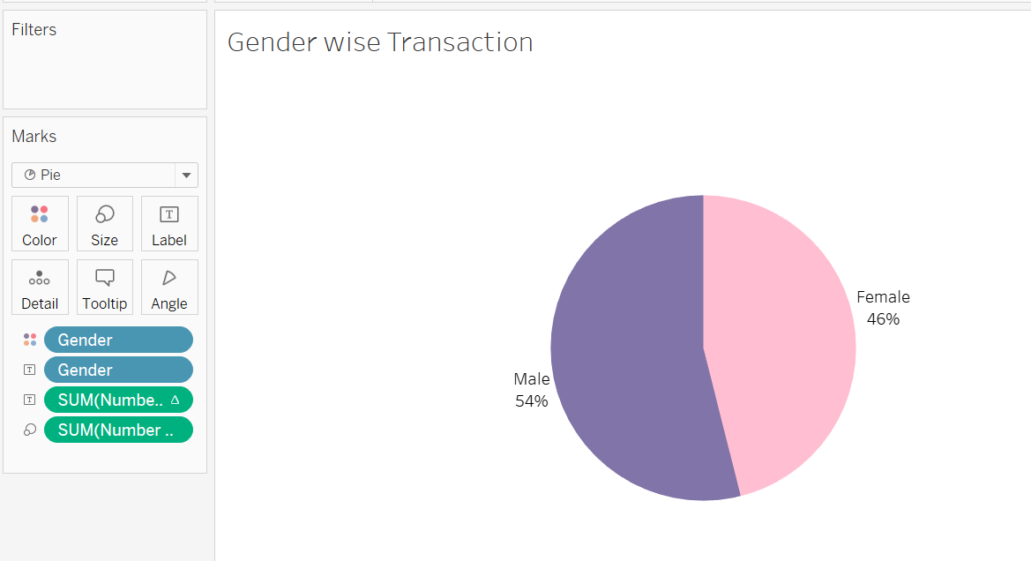

•**Create a Histogram displaying the distribution of age and transactions processed.**

Click on Age dimension and select Histogram from Show Me section.

Age (bin) gets created along with the Visual.

Right click on Age (bin) and select 'Edit' to change the size of bin and click on OK.

Fix the Age(bin) axis by clicking on the Axis and selecting 'Edit Axis'.  Enter the relevant Range under Fixed Range.

Drag and drop 'No. of Records' on label under Marks Card.

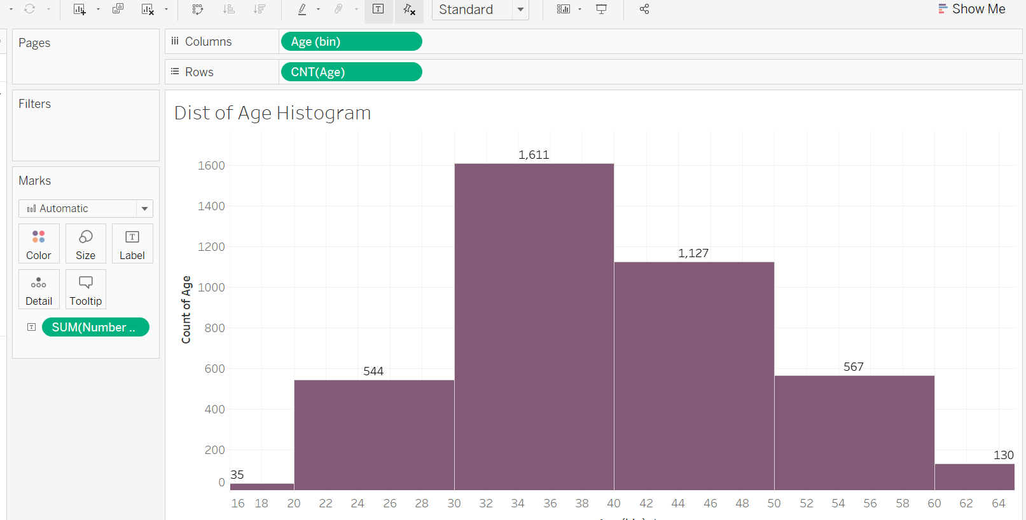

**Insights**

Highest No of transactions is by age group between 30 and 40.

**• Create a Histogram displaying the distribution of balance and transactions processed.**

Click on Balance measure and choose Histogram visual under Show Me section. Balance (bin) gets created.

Right click on Balance(bin) and select Edit. Change the size of bin to 10000 and click on OK.

Drag and drop 'No. of Records' measure to label under Marks card.

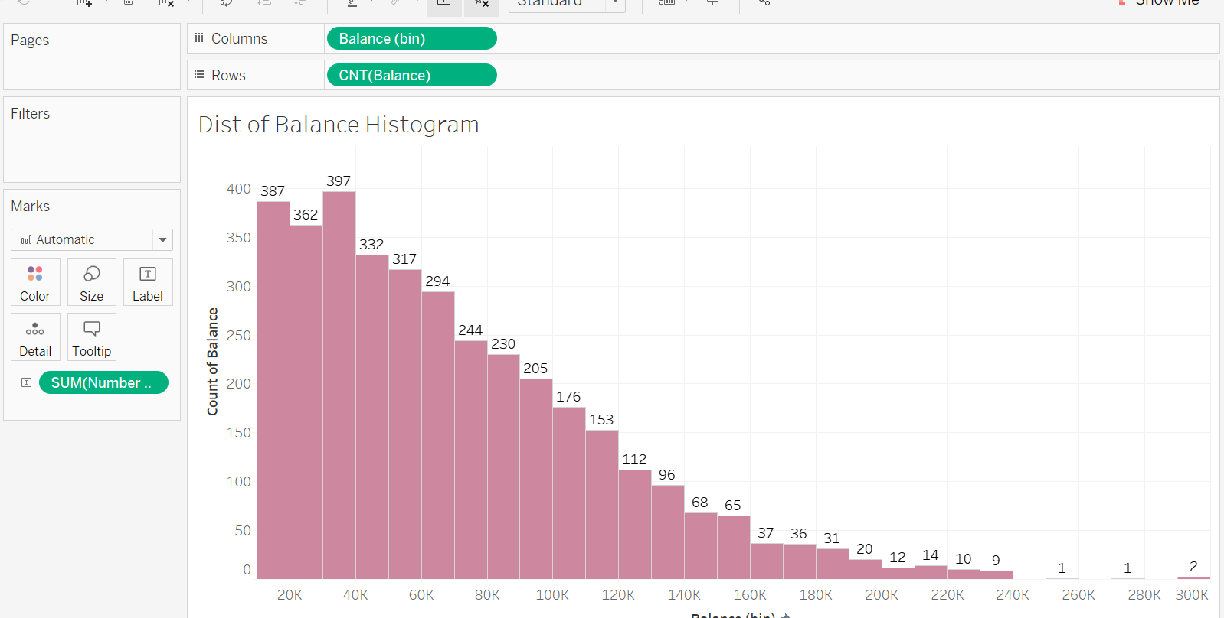

**• Create a Tree-map displaying the number of transactions processed within the classification of each job.**

Select 'Job Classification' from dimensions and 'No. of  Records' from Measures and choose Tree Map under Show Me section.

Drag and drop 'Number of records' onto label under Marks card.

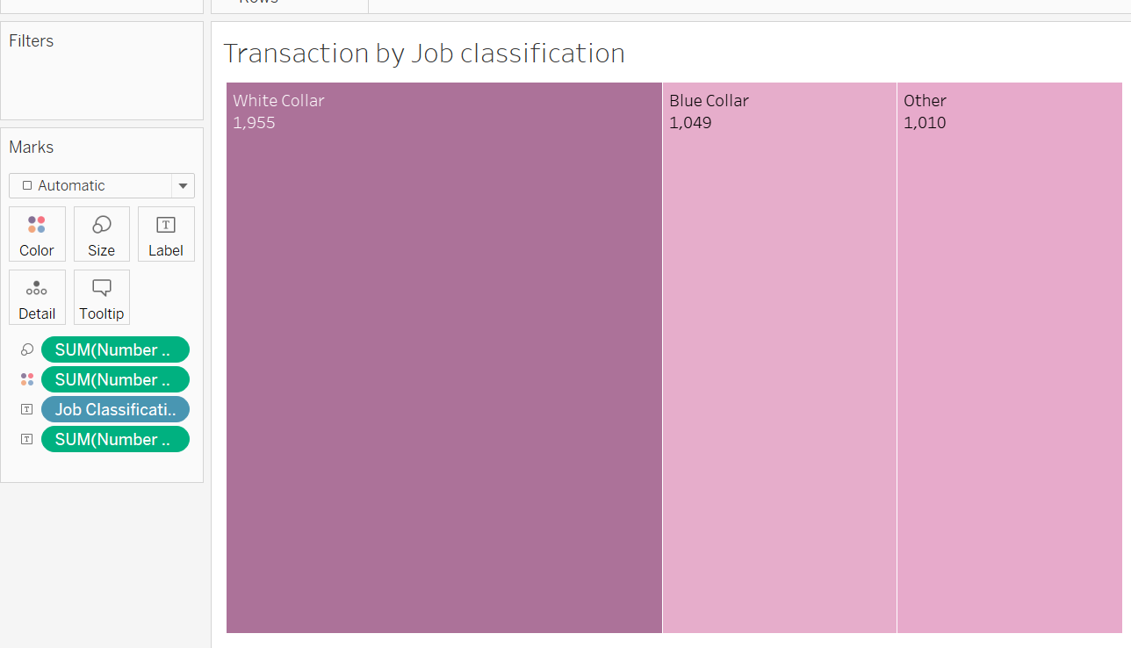

**• Create a Dashboard using all the charts. Make use of Action Filters as it will further improve the analyzing experience for the management.**

Click on New Dashboard icon and rename the dashboard as per your choice.

Click on each sheet one by one in order to add them to the dashboard.

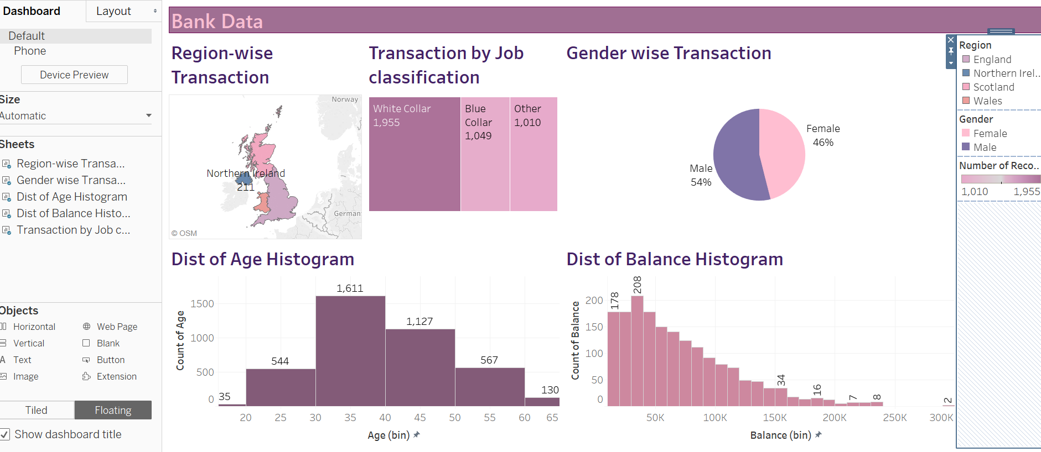

Turn on the funnel icon of a visual to enable Action Filter.

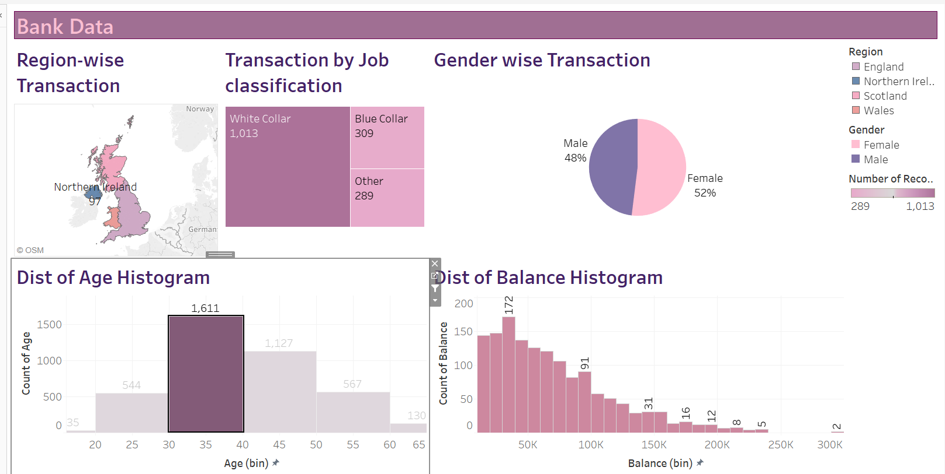

Action filter enabled on Distribution of Age Histogram and its effect on other visuals

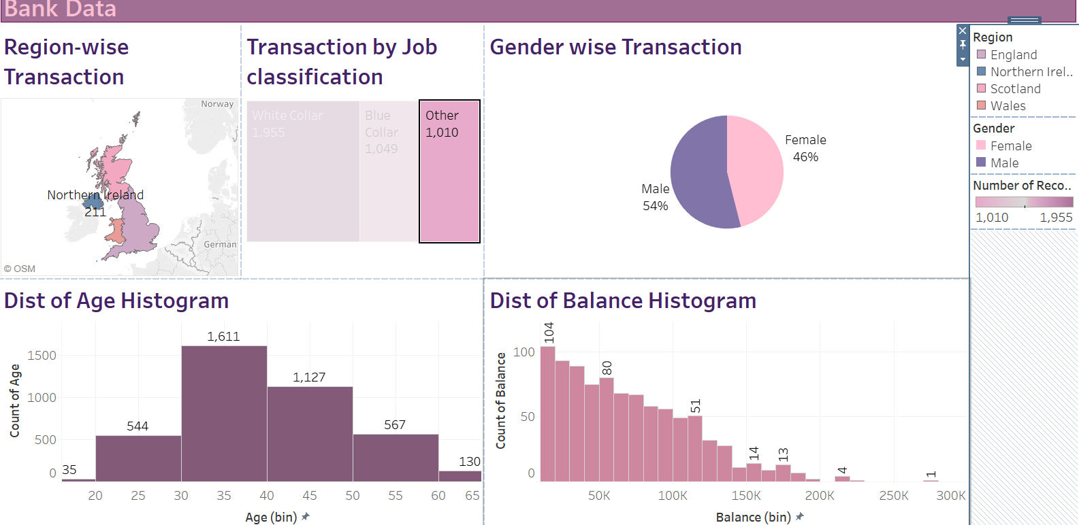

Job Classification as action filter affecting Distribution of Balance Histogram